C3PR v2

Installation Guide

caBIG™ is an initiative of the National Cancer Institute, NIH, DHHS

Development Team(s)
Development | Installation Documentation | Program Management
Kruttik Aggarwal² | Priyatam Mudivarti² | Bob Annechiarico¹
Manav Kher² | Manav Kher² | Jamie Cuticchia¹
Priyatam Mudivarti² |  | Patrick McConnell¹
Ram Chilukuri² |  | Ram Chilukuri²
Ramakrishna Gundala²
¹Duke Comprehensive Cancer Center | ²SemanticBits
Table of Contents

1. Introduction 1
Support for C3PRv1 1
Overview of C3PRv2 1
2. C3PR Software and Technology Requirements 2
Hardware Requirements 2
Software Requirements 3
Required Software 3
Optional Software 5
3. Installing C3PR 6
4. Graphical Installer 7
5. Common Problems with Installer (FAQ) 14
Manual Install 16
Download C3PRV2 codebase 16
C3PR Configuration 17
Setup Database 19
Create Tables 19
Populate Static Data 19
Configure Security for C3PRV2 19
Build / Deploy Code (Ant) 20
Securing Tomcat 20
Running C3PR 21
6. Contacting Technical Support 23
Appendix A – Configuring Multiple Tomcat Servers 24
Appendix B – Setting up CVS clients 26
Setup Tortoise CVS client 26
Setup Eclipse CVS Perspective 32

Introduction
This installation guide outlines the supported configurations and installing, setting up and configuring the application and databases for C3PRv2. All of the steps and screenshots included in this guide are Windows/Linux specific. If you are using a different platform, then modify the information as appropriate for your system.

Support for C3PRv1 | Although C3PRv2 is based on the underlying functionality of C3PRv1, much of C3PRv2 has been redesigned with more accepted open source technologies to meet the current standards for interoperability and web application development in alignment with caBig initiative. Hence we are not supporting C3PRv1 as a part of C3PRv2 development. However, critical functionality and use cases would be reused/refactored into C3PRv2, wherever possible.

Overview of C3PRv2 | C3PR is a central participant registry and underlying database that will allow the management of patient clinical trials registration information and protocol information across studies, sites, systems and organizations.  C3PR operates on its own data tables for Patient, Study and Registration Data. The implementation of the system will preserve the fundamental independence of the storage of the patient and registration information from the scientific and research data. System identifiers will be used to relate patient demographics and identifying information to eligibility, medical or treatment data.

C3PR Software and Technology Requirements

Hardware Requirements
There aren’t any stringent hardware requirements as C3PR is a lightweight web application, not intended to have a very large code base.
Processor | Pentium PIII, above 1.5 GHz
RAM | Minimum 512MB. (testing)  2 GB recommended
Operating System | Windows 2000,XP, Linux Mac OS X 10.4.x
Hard Disk Space | Minimum 500MB free space

Software Requirements
Required Software | You must download and install the required software that is not included with the C3PRv2 (listed in Table 1 ) The software name, version, description, and URL hyperlinks (for download) are indicated in the table

Software Name | Version | Description | URL
Java Software Development Kit (SDK): Java 2 Standard Edition (J2SE) | JDK 5.0 Update 11 or higher | The J2SE Software Development Kit (SDK) supports creating J2SE applications | http://java.sun.com/javase/downloads/index_jdk5.jsp
Oracle 9i/10g Database | 9i/10g | Oracle is a commercially-available relational database management system (RDBMS) that can be used on all major operating systems | http://www.oracle.com/technology/software/products/database/oracle10g/index.html
PostGreSQL | 8.2 | PostgreSQL is a powerful, open source relational database system. It has more than 15 years of active development and a proven architecture that has earned it a strong reputation for reliability, data integrity, and correctness. It runs on all major operating systems | http://www.postgresql.org/ftp/source/v8.2/
Tomcat Web Server | 5.5.20 |  | http://tomcat.apache.org/download-55.cgi#5.5.20
Ant | 1.6.5 | Ant is used for Building the C3PR application | http://archive.apache.org/dist/ant/binaries/
Internet Explorer/Mozilla Firefox Browser | 6.0/2.0 | Default browser(s) for C3PR webapplication. Currently we have not tested for IE 7.0
Maven* | 2.0.5 | Maven is used to build ServiceMix project within C3PR | http://www.apache.org/dyn/closer.cgi/maven/binaries/maven-2.0.5-bin.zip
ServiceMix* | 3.1 | Apache ServiceMix is an Open Source ESB (Enterprise Service Bus) that combines the functionality of a Service Oriented Architecture (SOA) and an Event Driven Arthitecture (EDA) to create an agile, enterprise ESB. | http://incubator.apache.org/servicemix/download.html
Table 1 Required software and technology for C3PRV2
Note - Either Oracle OR PostGreSQL (not both) is required as an RDBMS for C3PR application. Note that C3PRv2 doesn’t support SQL Server (which has been supported by C3PRv1)
*ServiceMix & Maven is not required to be installed if esb broadcast is disabled in C3PR. Read this section for more info

Optional Software | Optional software to use with the C3PR is listed in Table 2. The included (Incl.) column indicates (with a Yes) if the software is packaged with the SDK. No indicates that you must supply the software. A hyperlink is included for your reference to appropriate sources.

Software Name | Version | Description | URL | Incl.
Eclipse IDE | 3.2 | An open platform for tool integration which provides tool developers with flexibility and control over their software technology. We recommend the use of eclipse for general purpose development, build, test and synchronize with CVS repository | http://www.eclipse.org/downloads/ index.php | No
Tortoise CVS Client |  | An alternate CVS client if eclipse is not installed (Eclipse has a much simpler, rich CVS synchronization feauture) | http://prdownloads.sourceforge.net/tortoisecvs/TortoiseCVS-1.8.30.exe | No
Table 2 Optional software and technology for the C3PR

Note - Drivers for Oracle 9i/10g and PostGreSQL are included with the C3PR. If you are using a different version of Oracle, you must obtain the appropriate drivers. JDBC drivers can be downloaded from the Sun Developer Network at http://developers.sun.com/product/jdbc/drivers/index.html, or from the individual vendors’ sites (for example, the Oracle 9i driver classes12.zip can be downloaded from http://www.oracle.com/technology/software/tech/java/sqlj_jdbc/htdocs/ jdbc817.html). These drivers should be placed in the {project_home}/lib directory and the {CATALINA_HOME}/common/lib directory to enable connection to the appropriate database. In addition, some manual modification of the Hibernate configuration files may be necessary.

Installing C3PR
C3PRV2 has been tested with the operating systems and hardware specified in Table 1 of this guide. We cannot guarantee C3PRV2 will work If you are using variations of these operating systems and/or hardware.
There are two ways to install C3PRV2.
- Using the graphical installer
- Manual installation

The following section(s) will explain both the installation methods

Graphical Installer
C3PRV2 has a graphical installer to ease the installation process. Following are the steps to install C3PRV2 using the graphical installer

Step | Action
1 | Download the latest version of the installer from Gforge
- 3  2 | Verify that the JAVA_HOME environment variable is set and that your PATH statement includes the locations of the Java binaries. Optionally, set CATALINA_HOME if you wish to use an existing tomcat installation. Otherwise, the installer will install one for you.  To set environment variables in Windows:  - Select My Computer > Properties (from the shortcut menu) > Advanced tab.  - Click the Environment_Variables button.  - In the New System Variable dialog box, add the Variable and Variable Value.  Examples:  Variable = JAVA_HOME  Value = C:\j2sdk1.5.0_11  Variable=PATH;  Value=C:\j2sdk1.5.0_11\bin; (add to the beginning of existing value)  (Optional)  Variable = CATALINA_HOME;  Value = C:\apache-tomcat-5.5.20  To do this in Unix/Mac:  $ export JAVA_HOME=/usr/java..1.5  $ export PATH=$JAVA_HOME/bin:$PATH  $ export CATALINA_HOME =/usr/apache-tomcat-5.5.20  NOTE: Windows users please look at Chapter 5 for some common installation problems.
3 | Launch the installer by double clicking on the installer jar file (in windows and Mac) or by running the following command (applies to any OS)  java –jar c3prv2-installer-1.0.jar
4 | This will launch the graphical installation wizard  Follow the installation wizard to configure and install C3PRV2. Most screens during the installation process are self explanatory, some of the crucial steps are explained below
5 | 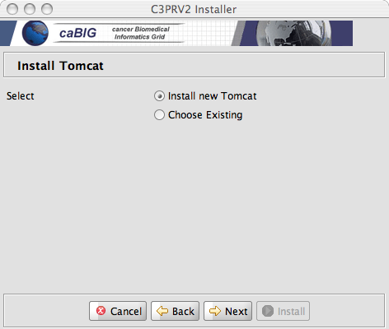  You can let the installer deploy and configure tomcat or chose an existing installation of tomcat on your system. If you choose to use an existing tomcat, see Tomcat SSL How To section to configure the tomcat server for the HTTPS protocol (C3PRV2 uses SSL to secure client server interaction)
6 | The most crucial step is to configure a database to use for C3PRV2. You will need to create an empty database in Oracle/PostgreSQL and the installer will run the database create/update scripts.  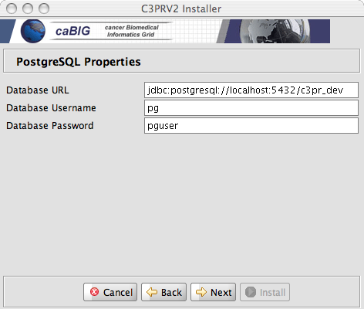  In the above example an empty database c3pr_dev exists in the local PostgreSQL database  Tip: Default values should be acceptable for most steps during the installation.
7 | Set your CATALINA_HOME environment (if not done so in Step 2).  If you did not have an existing tomcat, the installer would have installed a new tomcat in your chosen install directory.  To set environment variables in Windows:  - Select My Computer > Properties (from the shortcut menu) > Advanced tab.  - Click the Environment_Variables button.  - In the New User Variable dialog box, add the Variable and Variable Value.  Variable = CATALINA_HOME;  Value = C:\apache-tomcat-5.5.20  To do this in Unix/Mac:  $ export CATALINA_HOME =/usr/apache-tomcat-5.5.20
8 | Open command prompt, change directory to <CATALINA_HOME>\bin
9 | Run the following command to start tomcat server  startup.bat (windows)  startup.sh (unix)
10 | After your web application server has completely finished starting, open the browser with the following URL  http://localhost:9080/c3pr  NOTE: The installer’s version of tomcat runs on port 9080. Your existing tomcat might be on a different URL/Port
11 | At this point your installation should be complete.  See Common Problems with Installer (FAQ) section if you encounter problems during installation. Or email c3prv2-support@gforge.nci.nih.gov for support.

Common Problems with Installer (FAQ)

Sr.
1 | Question 1: My installation failed with the message “class sun.tools.javac.Main not on the classpath. Perhaps JAVA_HOME does not point to the JDK. Its currently set to c:/Program Files/Java/jre_1.5.0_11”  Answer: This can happen when installing in the Microsoft Windows Operating system. The solution to this problem is to copy the tools.jar file from $JAVA_HOME/lib/ to c:/Program Files/Java/jre_1.5.0_11/lib/ext directory. If the $JAVA_HOME/jre/lib/ext does not exist then go ahead and create it. Re-run the installer after doing this.  NOTE: c:/Program Files/Java/jre_1.5.0_11 can be different on your system
2 | Question 2: My installation failed at the final step with the message “edu.northwestern.bioinformatics.bering.Migration’?  Answer: This means the database create/update scripts did not work. Please check the database URL you entered in the installer. Also, make sure that an empty database is available to the installer. The installer can created the tables etc. but not create a database.
3 | Question: My installation failed at the final step with the message  “FATAL ERROR: c3pr_dev datbase does no exist”  Answer: This implies that you do not have an empty database created as instructed in Step 6 of the Graphical Installer Section
4 | Question: Installation failed at the final step with the message”  the password (pguser) is wrong for usernme 'pg' to create database c3pr_dev in PostgreSQL”  Answer: This seems like a PostgreSQL DB issue. Can you make sure you have the following line in your $POSTGRES_HOME/data/pg_hba.conf  local all all trust  This is assuming the Postgres DB and the installation is being done on the same server. If not then the pg_hba.conf should have something like  host all all 0.0.0.0 0.0.0.0 trust  Make sure the last keyword is “trust” and not “md5” or something else

Manual Install
If you wish to manually install C3PRV2, do the following

Download C3PRV2 codebase
Complete the following steps to download the C3PR:

Step | Action
1 | Using your CVS Command Line Tool (or tortoise), connect to CVS as ‘anonymous’ (no need of a password) using the following settings:-  Export CVS_RSH=ext  cvs -d:ext:anonymous@cbiocvs2.nci.nih.gov:/cvsshare/content/gforge/c3prv2 "checkout" "-r" "<branch name>" "-P" "c3prv2/codebase"  Note – Replace <branch name> with the current release’s branch. Like c3prv2_elaboration_iteration5  Separate instructions to download and configure cvs clients for Tortoise and Eclipse are given in the Appendix CVS
- 3  2 | Verify that the environment variables ANT_HOME and JAVA_HOME, CATALINA_HOME are set and that your PATH statement includes the locations of the Ant and Java binaries. For example., PATH should include C:\apache-ant-1.6.2\bin; C:\j2sdk1.5.0_11\bin.  To do this in Windows:  - Select My Computer > Properties (from the shortcut menu) > Advanced tab.  - Click the Environment_Variables button.  - In the New User Variable dialog box, add the Variable and Variable Value.  Examples:  Variable = ANT_HOME; Variable Value = C:\apache-ant-1.6.2  Variable = JAVA_HOME; Variable Value = C:\j2sdk1.5.0_11  Variable = CATALINA_HOME; Variable Value = C:\apache-tomcat-5.5.20  To do this in Unix/Mac:  $ export ANT_HOME=/usr/ant-1.6.2  $ export JAVA_HOME=/usr/java..1.5  $ export CATALINA_HOME =/usr/apache-tomcat-5.5.20

C3PR Configuration
C3PR consists of multiple sub projects, namely core, web, grid etc. Each Project is configured to have a property file to externalize properties needed for the sub project. These properties are injected to the application via Spring. C3PR works be externalizing these properties from Spring application context to a property file which in turn is build via an ant file.

While installing C3PR, the user needs to set all the properties just in one single place ie, the build.properties file. This file can be located at

build.properties - codebase/antfiles/build.properties

The C3PR example is configured to work with either Oracle 9i/10g or PostGreSQL 8.2, however, you must assign the appropriate values for the database properties in the corresponding section
Sample contents of this file:

Entry | Sample Values | Default Values/Ignore?
datasource.url | jdbc:oracle:thin:@localhost:1521:c3pr - Oracle  jdbc:postgresql://localhost:5432/c3pr - PosgreSql
datasource.username | Enter username
datasource.password | Enter password
datasource.schema | (optional), by default it connects to the schema same as username | (optional)
datasource.dialect | org.hibernate.dialect.Oracle9Dialect - Oracle  org.hibernate.dialect.PostgreSQLDialect - PosgreSql | org.hibernate.dialect.PostgreSQLDialect
datasource.driver | oracle.jdbc.OracleDriver – Oracle  org.postgresql.Driver - PostGreSql | org.postgresql.Driver
broadcastEnable | false | false (recommended)
esb.brokerUrl | tcp://cbiovdev5032.nci.nih.gov:61618 | Ignore this value
hotlinks.psc | http:// 74.93.192.33:8041/studycalendar/pages/schedule | Ignore this value
hotlinks.caaers | http:// 74.93.192.33:8030/caaers/pages/ae/list | Ignore this value
hotlinks.c3d | https://octrials-train.nci.nih.gov/opa45/rdclaunch.htm | Ignore this value
grid.idpUrl | https:// 74.93.192.33:8446/wsrf/services/cagrid/AuthenticationService | Ignore this value
grid.ifsUrl | https://localhost:8443/wsrf/services/cagrid/Dorian | Ignore this value
authorizationSwitch | true, false | true (recommended)
log4j.file | /usr/local/apache-tomcat-5.5.23/logs | Change this value as per your CATALINA_HOME installation folder
ctmsi.commons.version | 0.3 | Ignore this value

Note – Most of the values with the Urls are currently not needed as Security is not enable for this installation. Leave these values with the defaults provided for now. Make sure you do not have settings given for both Oracle and PostGreSQL and comment out the unwanted lines preceded by “#”.
Also note that all the above values should not have any trailing spaces before and after. For example

datasource.dialect=org.hibernate.dialect.Oracle9Dialect

If you notice the line above, there is an extra space towards the end. This is a casual error that may occur while performing a copy/paste and should be thoroughly checked

Setup Database
There are two ways to create the database. Either use the following Ant target (and move to the next section) or create tables manually as explained later in this section.

cd codebase\antfiles
ant createOrUpdateDatabase

NOTE: Skip to the next section if you are successfully able to run the ant target

Create Tables
Once a user id with privileges to create tables is created, run the following script to create tables in the schema

For Oracle,
codebase\projects\core\db\oracle\c3pr_create_ddl.sql
For PostGreSQL,
codebase\projects\core\db\PostGreSQL\c3pr_create_ddl.sql

Populate Static Data
C3PR Application needs a predefined static data (like healthcare sites, addresses), for this the following static-data script must be run.

For Oracle,
codebase\projects\core\db\oracle\static-data.sql
For PostGreSQL
codebase\projects\core\db\PostGreSQL\static-data.sql

Configure Security for C3PRV2
For Oracle,
Run the scripts in the following folder in their numerical order
codebase\projects\core\db\oracle\csm

For PostGreSQL
Run the scripts in the following folder in their numerical order
codebase\projects\core\db\ PostGreSQL \csm

Build / Deploy Code (Ant)
Perform the following steps to build your system.

Step | Action
1 | Open command prompt, change directory to codebase\antfiles  (Note – You can also use your your IDE’s built in Ant tool and skip the above test)
2 | Run the following ant task by executing the following command  Ant deploy-webapp

This deploys the software to the webapp directory of the web application server installation specified in the CATALINA_HOME\webapps\c3pr director

Securing Tomcat
c3pr requires a secure tomcat container and uses https by default. To secure your Tomcat installation, do the following

Step | Action
1 | Open command prompt, change directory to codebase\antfiles
2 | Run the following command  ant tomcat.security  NOTE:There will be instructions after you run this target on how to edit your tomcat.properties
3 | Next follow these directions on configure SSL for your tomcat (if not done in a previous install)  http://tomcat.apache.org/tomcat-4.0-doc/ssl-howto.html

Running C3PR
Perform the following steps to run the system
Step | Action
1 | Open command prompt, change directory to <CATALINA_HOME>\bin
2 | Run the following command to start tomcat server/bin  Startup.bat
3 | After your web application server has completely finished starting, open the browser with the following URL  http://localhost:8080/c3pr  C3PR home page should be displayed  Note – Currently login is not enable, click on login without any username/pwd to continue using the application

Note - Once the application is running, follow a series of workflows like
- Create a Default Study
- Register a Participant for Study (Create a new Participant)
For a detailed set of Steps to be followed above, refer the use cases document or contact support for individual step.

The following figure displays the browser window that opens with a successful system test
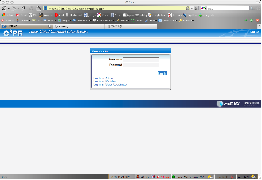

Contacting Technical Support
Please mail c3prv2-support@gforge.nci.nih.gov for support on Installation or general C3PR technical Support queries

Appendix A – Configuring Multiple Tomcat Servers
More often there is a requirement to configure multiple tomcat servers if a tomcat instance is already running another application. A few modifications need to be done to achieve this. It is recommended to install a separate tomcat instance for C3PR. Make a note of the installation directory.

- Setting Tomcat Home:
By default C3PR assumes a single instance of Tomcat installation and looks for a CATALINA_HOME environment variable. If there exists another tomcat instance already, there is a good chance that it is taking up this environment variable. To override this, we need to manually enter the location of Tomcat folder in the corresponding ant file
And disable Catalina_home temporarily before running tomcat of C3PR. (This can be done by removing this variable temporarily from windows path. You can add this later once c3pr tomcat is running but remember to make this change evertime)

Open the files
- In codebase/projects/web/build.xml

Change the following lines
<property name="deploy.path" value="${env.CATALINA_HOME}/webapps" />
to
<property name="deploy.path" value="C:/apache-tomcat5.5.23/webapps" />

<fileset dir="${env.CATALINA_HOME}/common/lib">
to
<fileset dir="C:/apache-tomcat5.5.23/common/lib">

- In codebase/antfiles/build.xml
<property name="deploy.path" value="${env.CATALINA_HOME}/webapps" />

- In codebase/antfiles/core/build.xml
Same as above, replace instances of CATALINA_HOME

Note – Remember the above location is a sample of the tomcat location folder, in your case it should be changed the tomcat installation folder. (both on unix and windows)

- Changing port numbers
The next step is to change the port nos of this installation. Go to tomcat’s installation folder/server.xml

Change the port nos

1)
<Server port="8005" shutdown="SHUTDOWN">
to
<Server port="18005" shutdown="SHUTDOWN">

2)
<Connector port="8080" maxHttpHeaderSize="8192"
to
<Connector port="18011" maxHttpHeaderSize="8192"

3)
<Connector port="8443" maxHttpHeaderSize="8192" to
to
<Connector port="18443" maxHttpHeaderSize="8192" to
4)
<Connector enableLookups="false" port="8009" protocol="AJP/1.3" redirectPort="8443"/>
to
<Connector enableLookups="false" port="18009" protocol="AJP/1.3" redirectPort="8443"/>

Note that all the above changed port numbers are assumed to be unique in your system if this is being used by your existing tomcat installation, it needs to be changed to a non conflicting port number.

That’s all you would need to install and run another Tomcat instance for C3PR. The rest (starting/stopping) should be the same

Appendix B – Setting up CVS clients

Setup Tortoise CVS client
There are 2 steps to this procedure.
First one is downloading and installing the TortoiseCVS wizard.
Second one is specifying the connection parameters and checking out c3prv2_elaboration_iteration3 from windows explorer.

Step 1: Downloading and installing TortoiseCVS.

(a) For Windows 95, 98, ME, NT, 2000, XP, and 2003, go to link http://www.tortoisecvs.org/download.shtml and click on the link - TortoiseCVS-1.8.30.exe to download it.

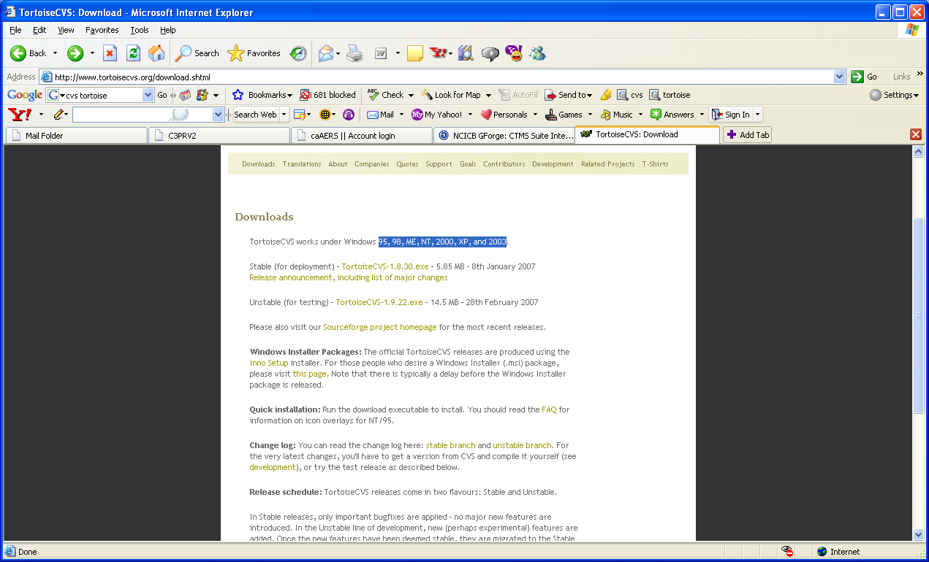

That link should take you to the following page
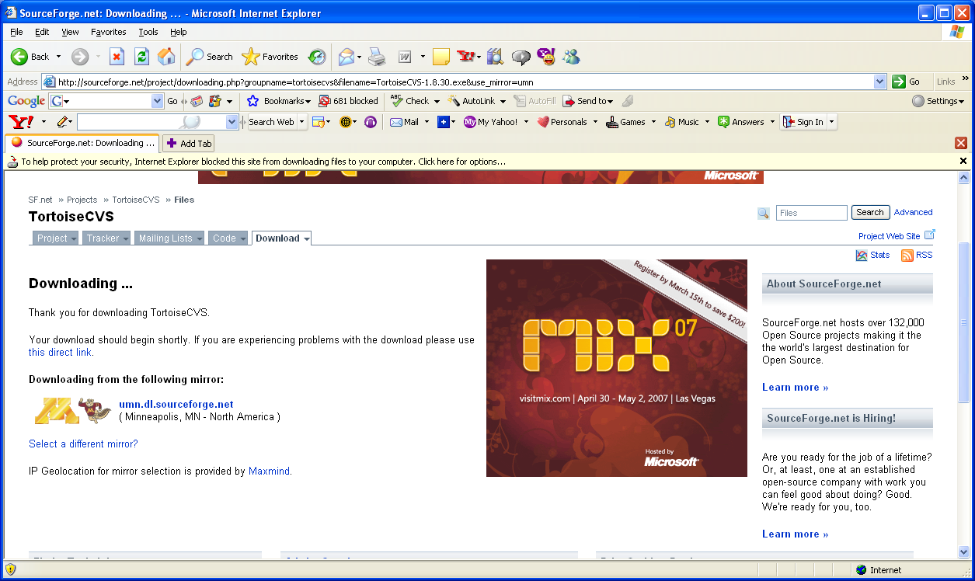

If you have the popup-blocker turned on, you may not be able to see the popup window to download the page. Then right click on the yellow bar, which says that windows blocked the popup as shown in the above image, and select download file. Or if you turn-off the pop-blocker temporarily, it enables you to see the following popup window.

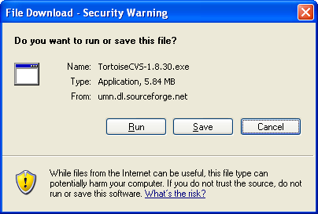

(b) Click-on save and select the destination folder, for example c:\ and save the TortoiseCVS-1.8.30.exe. Now navigate to the folder where you saved TortoiseCVS-1.8.30.exe, double-click on the .exe to run it. Select the language as English, then you should see
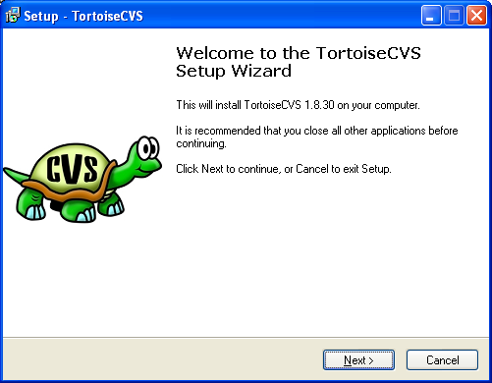

(c) Click on Next, and click on browse to select the destination folder to install TortoiseCVS, for example, c:\. Then the setup wizard would install the TortoiseCVS in C:\TortoiseCVS.

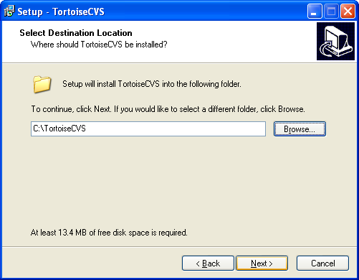

- Click on next. Select Full installation.
- Click on Next, the setup wizard will copy some files and prompt for you to restart the computer to complete the installation. You can select restart computer now or choose to restart it later.Save and close all other applications before restarting your computer. Click on Finish. This will restart your computer if you selected, restart now option.

- Restart your computer.

Step 2: Specifying the connection parameters and checking out the c3prv2_elaboration_iteration3 branch into your local folder.
(a) Once you restarted the computer, navigate to the folder, where you want to download the c3prv2 codebase, for example, c:\c3prv2.
(b) Right click on the folder and select CVS Checkout and you should see the following window.

(c) Under module tab type in (or select in case of protocol) the following values in the respective fields:

Select the Protocol as Secure shell(:ext)
Type in the field Server: cbiocvs2.nci.nih.gov
In the Repository folder field, type in: /share/content/gforge/c3prv2
Type in the User name field: anonymous
Type in the Module field: c3prv2

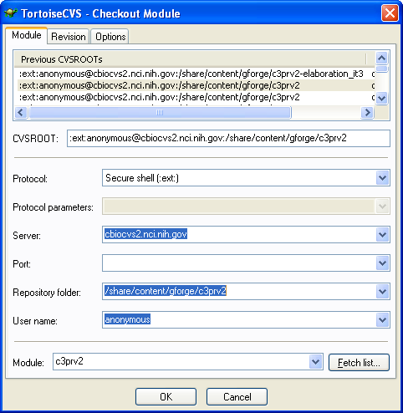

You can see the CVSROOT being automatically built as you enter each field.

Make sure there are no empty spaces or any other characters.

(d) Click on the revision tab. Under Revision tab click on the button, Choose branch or tag, and specify the branch or tag name as: c3prv2_elaboration_iteration3

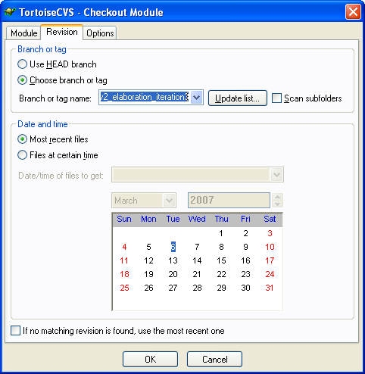

(e) Click on ok.
When it prompts for password, type anonymous

The TortoiseCVS wizard will start checking out the project in the folder you selected. In this case into c:\c3prv2. Wait for it to finish checking out. It may take a few minutes.

If you have successfully checked out c3prv2_elaboration_iteration3 , the tortoise will give a message that the download is complete. Click on ok to close the TortoiseCVS project checkout window. If for some reason the check out doesn’t start, or stops in the middle, check the connection parameters, network connection and repeat step 2 again.

You should have successfully checked out the c3prv2_elaboration_iteration3 from your explorer.

Setup Eclipse CVS Perspective
The following steps assume you are familiar with eclipse IDE as your development environment and you would like to use it’s cvs perspective to download files from cvs repository. If you don’t have eclipse IDE installed then it is recommended to use Tortoise CVS client as it is simple to setup and download

Step 1 – Got to Eclipse CVS Perspective by clicking on the menubar Window->Open Perspective-> CVS Perspective

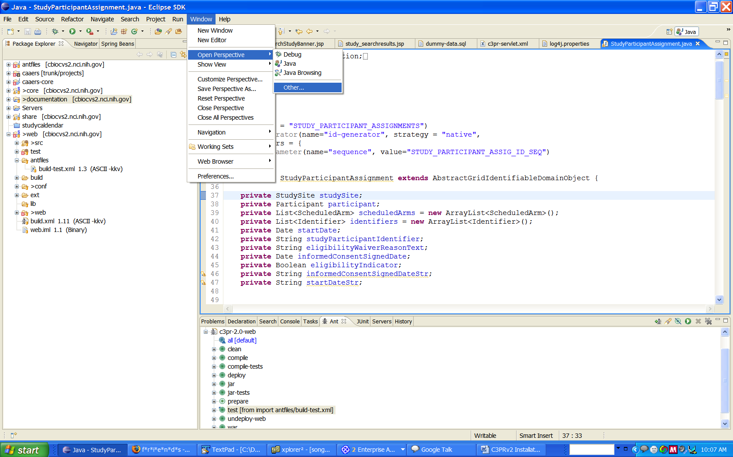
Step 2 – Create a new repository

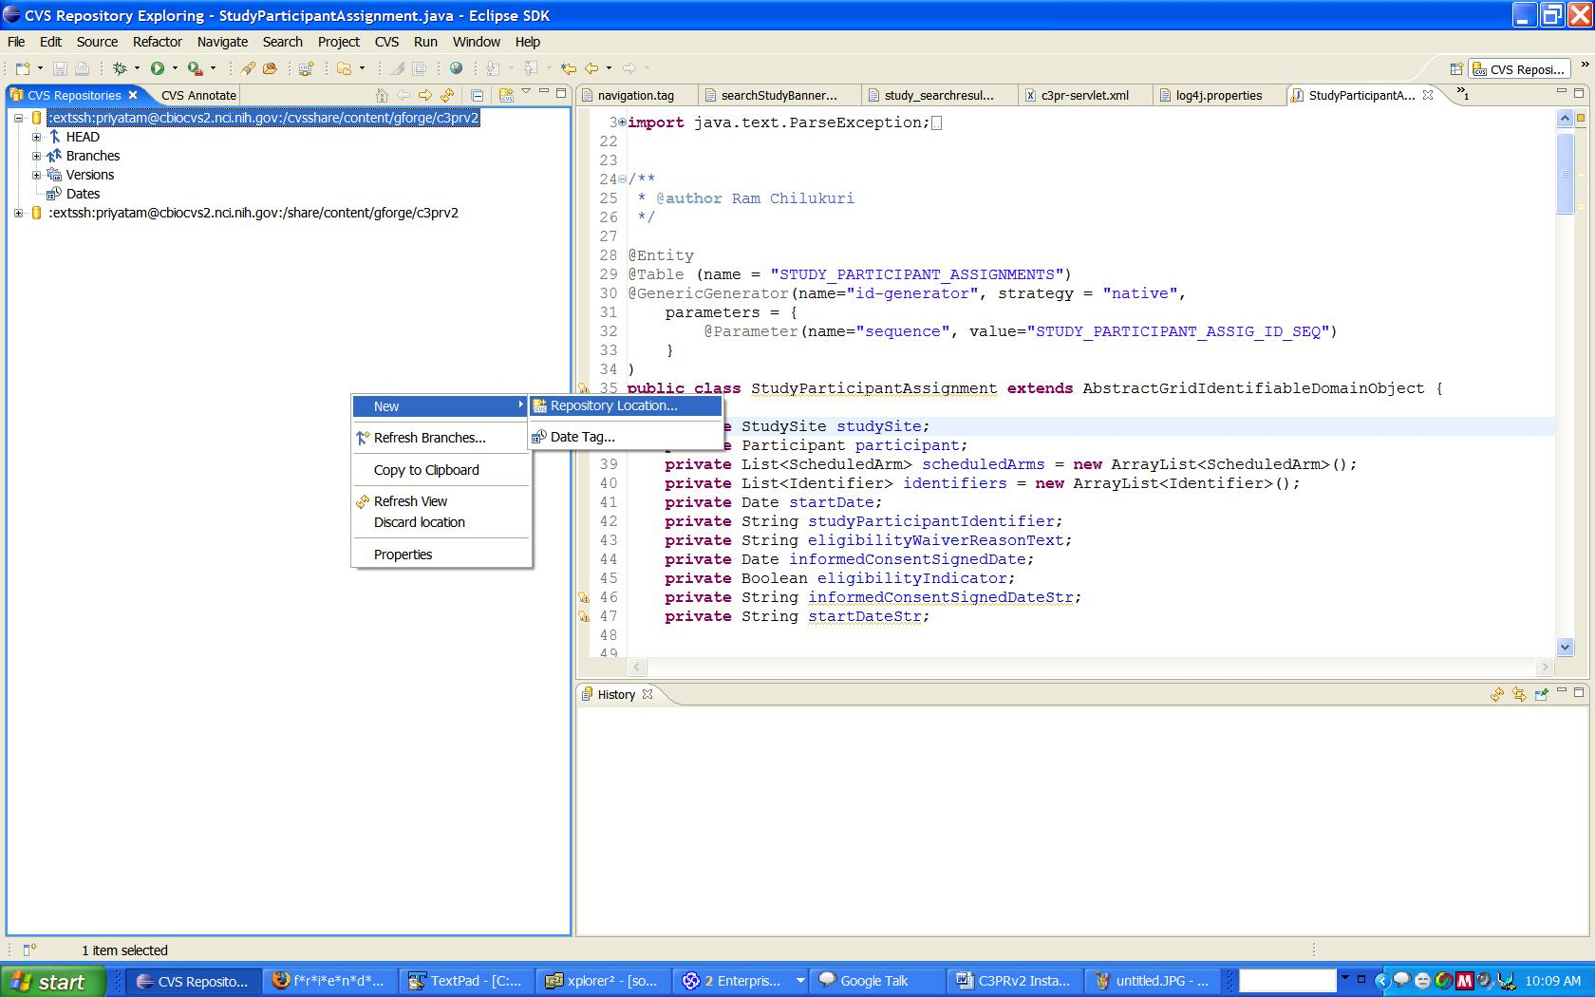
Step 3 – Enter the details for Repository location as follows. Enter Password as “anonymous”

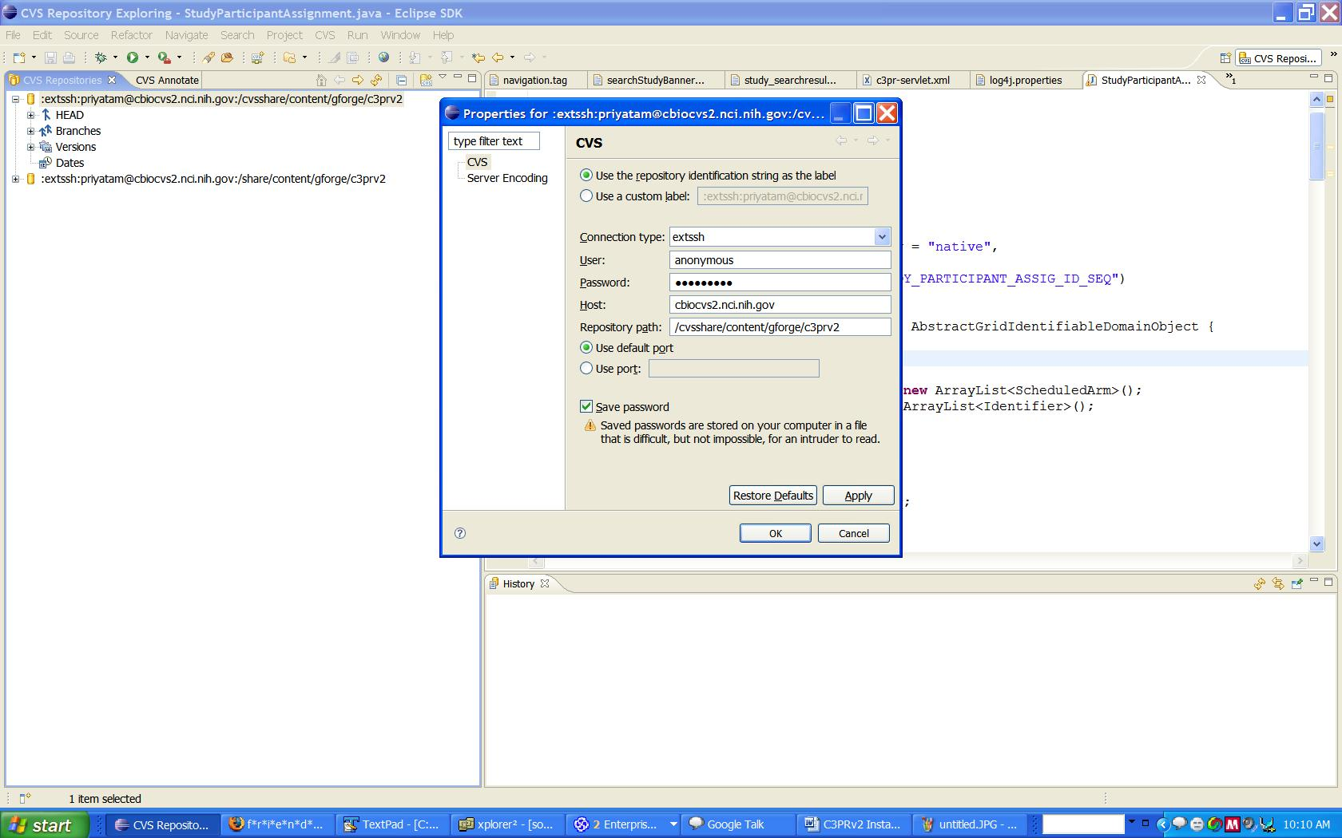

Step 4 – Refresh the Branches Section
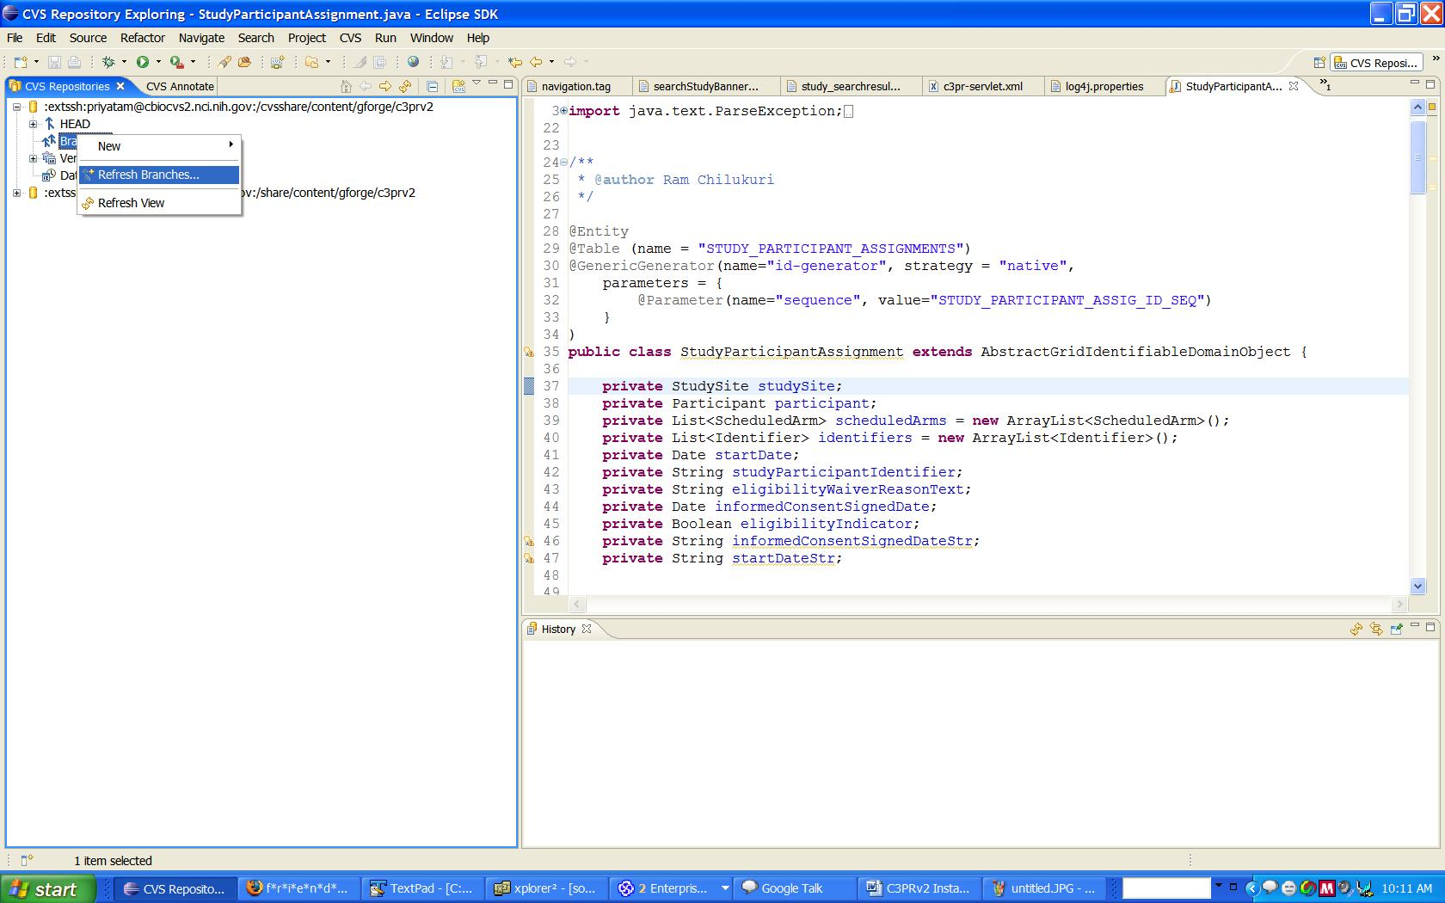

Step 5 – Deep Search for Tags in Branches
Once you click finish, you will get a dialog. Click on ‘deep search’ and wait till the process is completed (This might take some time to finish)
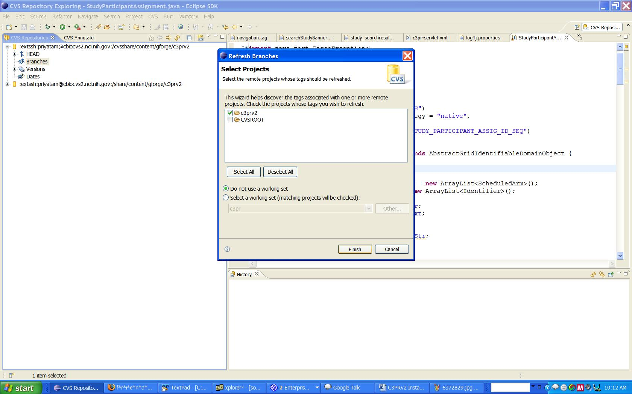

Step 6 – Once done, right click on the desired branch, checkout the entire ‘codebase’ folder

